**Master Record:: Lead**

|  |  |
| --- | --- |
| Lead Status | Lead Score |
| Not Interested | 0 |
| Dump | 1 |
| Warm | 2 |
| Hot | 3 |

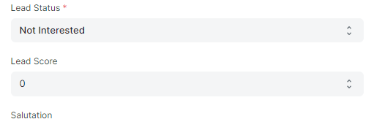

We have multiple options in Lead Status and Lead Score Custom fields, shown as Above table.

As We want to make a relation between Lead Status and Lead Score.

Whenever we select the lead status as “Dump” ,“0” should gets update on Lead Score.

Like wise for “Not Interested” , “1” should gets update on the Lead Score.

Similarly whenever the Lead Status was “Warm”, “2” will be respective output of Lead Score.

For “Hot” – “3” Should gets update in Lead Score.